Brain Dumps HR:

- In Service Now SIM, which methodologies are used? – single select (pg 39)
  - Agile
  - Agile and waterfall
  - Waterfall and (Rapid Application Development) RAD
  - One more option

- In I9ln Internalization plugin where are the Translated KB articles viewed? – single select
  - Translated Versions, on the KB related List

- For a non-English user, while using Translated text, is free form text translated? – single select
  - No, journal fields are not translated
  - Yes, journal fields are translated
  - No, text fields are translated
  - Yes, text fields are translated

- HR benefits in scoped app – select all that apply

- How many COE can be selected in HR template – single select

  - One
  - Two
  - Three
  - Unlimited

- How is the Lifecycle Events application shown in the application picker – single select
  - Human Resources: Lifecycle Events
  - Human Resources Scoped App: Lifecycle Events
  - Human Resources: LE
  - Lifecycle Events

- What is the minimum configuration required to create an HR case by an HR Professional – single select
  - HR service and HR template
  - HR Service
  - HR service, record producer and HR Template
  - HR service, record producer and HR Template and HR activities

- HR core case table is an extension of – single select
  - Task
  - Incident
  - HR Lifecycle Events
  - HR Service

- Implementation Data Packs is accessible by? – single select(select the best that applies)
  - ServiceNow Employees only
  - Partners only
  - ServiceNow Employees, Partner, customers

- Text can expand and shrink up to how much percent in translated text? (pg - 187) – single select
  - Up to 300%
  - Up to 250%

- Where can a no role user view cases HR cases assigned to him? – single select
  - Tasks
  - Portal
  - HR Templates
  - HR Services

- HR topic categories are a group of? – single select
  - Group of HR Categories
  - Group of HR Templates
  - Group of HR Tasks
  - Group of HR Services
- If a Lifecycle Events plugin is installed, then LE Admin role is added to? - single select
  - HR Admin
  - Admin
  - HR Basic
  - HR Manager
  - Role is not added to anyone

https://docs.servicenow.com/bundle/kingston-hr-service-delivery/page/product/human-resources/concept/c_LifeCycleEventRoles.html

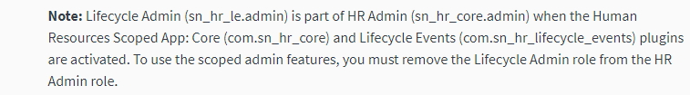

- Where do you view status of sync after executing Dry Run? – single select (Pg 160)
  - Job Tracker
  - Logs
  - Schema Mappings
- Which module includes Integrations, inbound, outbound configurations used to integrate with 3rd party applications? – single select
  - HR Integration Services
  - HR Webservices

- Select all that applies to Chat Queue –
  - Connect Support license purchased
  - No. of available agents
  - Availability schedule assigned
  - Assignment group must be defined for HR chat queue
  - Install HR connect plugin

- What is included on the Configuration View of Guided Set up – select all that apply (pg - 82)
  - Overviews
  - Gauges
  - Lists
  - Forms
  - Properties

- If we don’t buy the enterprise Onboarding and transitions plugin, what is already present in the Lifecycle events plugin? – single select (pg 99)
  - Lifecycle events plugin needs to be installed
  - Onboarding HR Services is installed
  - Onboarding HR Services is predefined and other services can be configured
  - Onboarding and offboarding are included
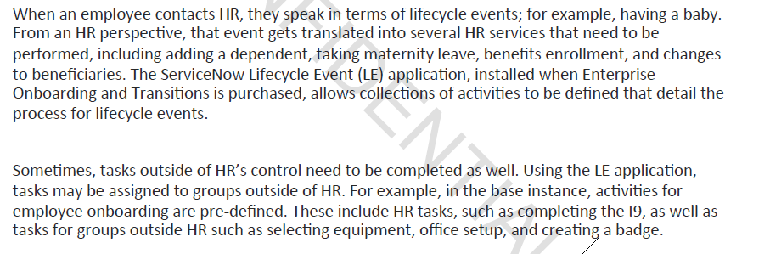

- What role is required for HR users to view HR dashboards – single select
  - HR Admin
  - HR Manager
  - HR Basic
  - Le admin
https://docs.servicenow.com/bundle/kingston-hr-service-delivery/page/product/human-resources/concept/c_ManageRoles.html

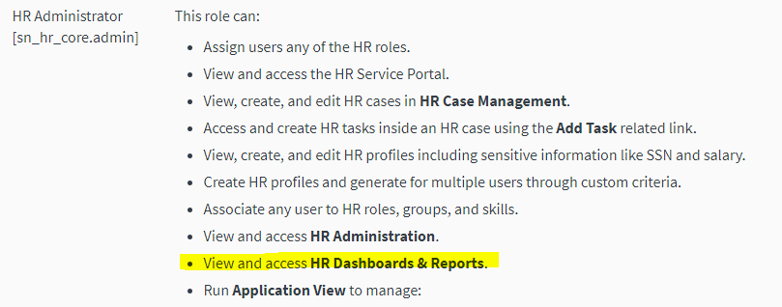

- Differentiators of HR profile and User Profile – select all that apply
  - HR profile contains confidential employee data
  - HR profile contains employee credential data
  - HR profile contains employee HR details
  - HR profile contains Charts

- Integration Categories: select all that apply (pg - 147)
  - Authentication
  - Data Integration
  - Web services

